Business Intelligence in Decision Making

Ruth’s Chris: The High stakes of international expansion

Golden Gate University

Fall 2016

Eren Zedeli

ID: 580199

ITM 345

Instructor: Heinz Schwarz

Table of contents

|  |  |
| --- | --- |
| Abstract | 3 |
| Description of the problem | 4 |
| Model based decision-making | 4 |
| Creating a Decision Matrix | 5 |
| Charts and Data | 7 |
| Conclusion | 11 |
| Reference | 13 |

Abstract

The purpose of this research paper is to highlight how a company uses Business Intelligence (BI) for its business decisions. According to Mulcahy (2007), organizations use business intelligence to support their business decision processes. Business intelligence helps companies analyze data to decide optimal business decisions, identify new business opportunities, cut costs, and improve business decisions. Specifically, I am going to analyze Ruth’s Chris business decision, which is to decide international expansion of company. Dan Hannah, vice president for business development at Ruth’s Chris, is trying to deal with international expansion. Based on possible alternative countries, Hannah will decide to expand. In order to show the benefits of business intelligence in decision-making, I am going to use the technique called “decision matrix,” which is one types of the “Model Based Decision Making” to find the optimal business decision. I will discuss different scenarios depending on given data and predict what could happen if Hannah chose to expand that country. I have 33 different countries with their per capita beef consumption, population, urbanization, per capita GDP, meat consumption growth rate. Also, I am going to use this data to create charts to help me with model based simulation technique. Ultimately, I am likely to find the optimal business decision for expansion.

1. **Description of the problem**

In the case “Ruth’s Chris: The High Stakes of International Expansion”, Kupetz and Alon (2006) wrote that Ruth’s Chris, a steak house in the USA which was founded by Ruth Fertel who was born in New Orleans, so she has opened her first restaurant in there. At first, Ruth Fertel had just one small restaurant. After years with problems and some unsuccessful business trials, one of the Ruth’s Chris’s ordinary customers has showed up with an offer. The customer requested Ruth to give him a franchise. In fact, everything had started with this. After that point, Ruth’s Chris’s business increased incredibly. Accordingly, Ruth’s Chris has opened many new restaurants. As a result, the restaurant became a public company from a private company. In addition, Ruth has given many franchises, so that the restaurant has grown day by day. Now, Ruth’s Chris is a successful company. Ruth’s Chris is the biggest steak house in the USA with many restaurants all over the world. In 2006, Dan Hannah, vice president for business development, had to decide Ruth’s Chris’s expansion to a different country.

1. **Model based decision-making and Decision Matrix**

According to Decision-making confidence (n.d.), decision-making is the process of choosing the optimal option from several options. Marci (2016) pointed out that one of the biggest challenges business owners, executives, and manager are having is decision making. One of the types of model-based decision-making is decision matrix. Marci went on to claim that if you have more than one alternative from which to choose, a decision matrix is likely to help make the decision clear and highlight the important points for your final decision. Decision matrix contains tables used in weighing every alternative to find the optimal choice (Decision matrix, (n.d.)). The purpose of the decision matrix is to help managers evaluate alternatives when there are various alternatives, and weigh factors and criteria that will help for the final decision.

* 1. **Creating a decision matrix**

Before I created the decision matrix, I had identified the decision criteria, which are:

* Per capita beef consumption: most important criterion
* Per capita GDP: the second important criterion
* Population: the third important criterion
* Urbanization: the fourth important criterion

Since Ruth’s Chris is a steak house and serving beef, beef consumption is the most important criteria. Like other steak houses, eating in a steak house might be quite expensive, so people in the possible expansion country have to have high income. My third important criterion is population. Higher population means that Ruth’s Chris can target more customers. Finally, my fourth criterion is urbanization, which means the amount of population that lives in the towns and cities. It is important Ruth’s Chris will serve in the big cities. If the urbanization rate is high, that means people live in big cities with a big population.

During my research, I have found the decision matrix sample from [www.velaction.com](http://www.velaction.com). After that, I reorganize the decision matrix based on my business decision.

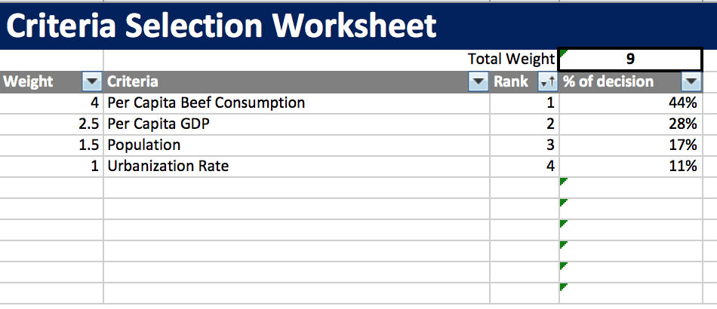Exhibit 1: Criteria Selection

After I identified my decision criteria, I ranked every alternative depending on the importance of each criteria (1: most important). Then I added weight index. For example, I assume that beef consumption is 4 times more important than urbanization rate. Finally, I got the big picture of how important each criterion is. Per capita beef consumption is 44% of the total weighting system.

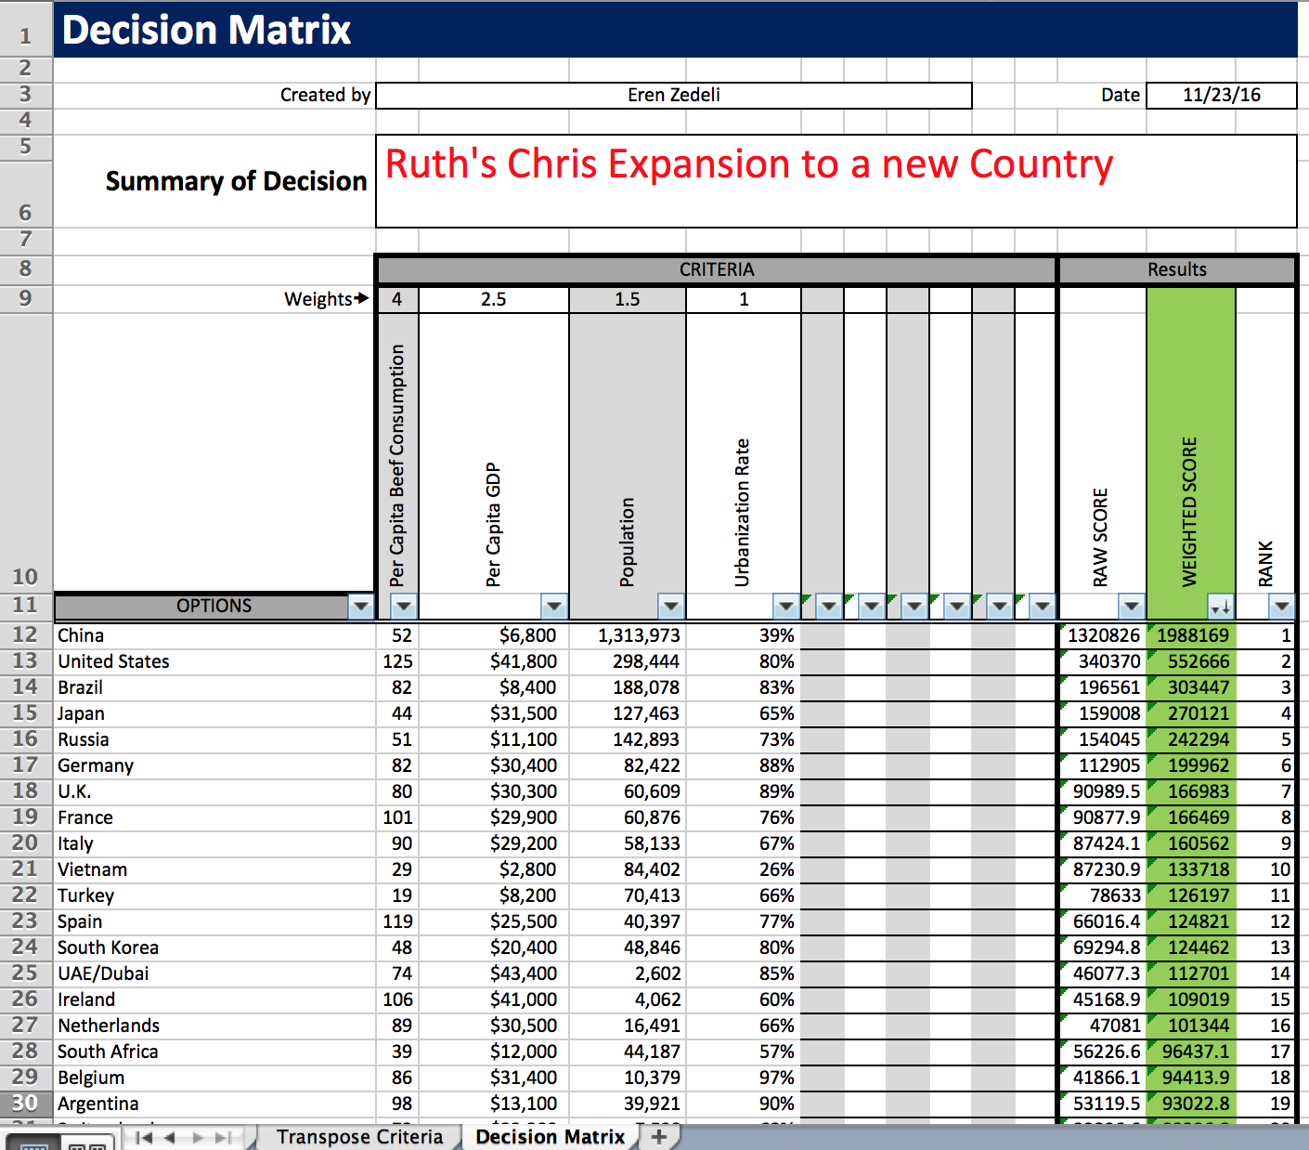 Exhibit 2: Decision Matrix

After that, I used my weight index to multiply with the value of each alternative, and found my weighted score.

1. **Charts and Data**

I have used the data in Google Fusion Tables, and created charts to support model based decision-making.

Exhibit 3 shows the data for each country’s population (1000s), urbanization rate, per capita beef consumption (kg), and per capita GDP (US$). I created this table with Google Fusion, and it gives me clear information for each alternative. Before I make my final decision, I am likely to have better view of the data and alternatives. 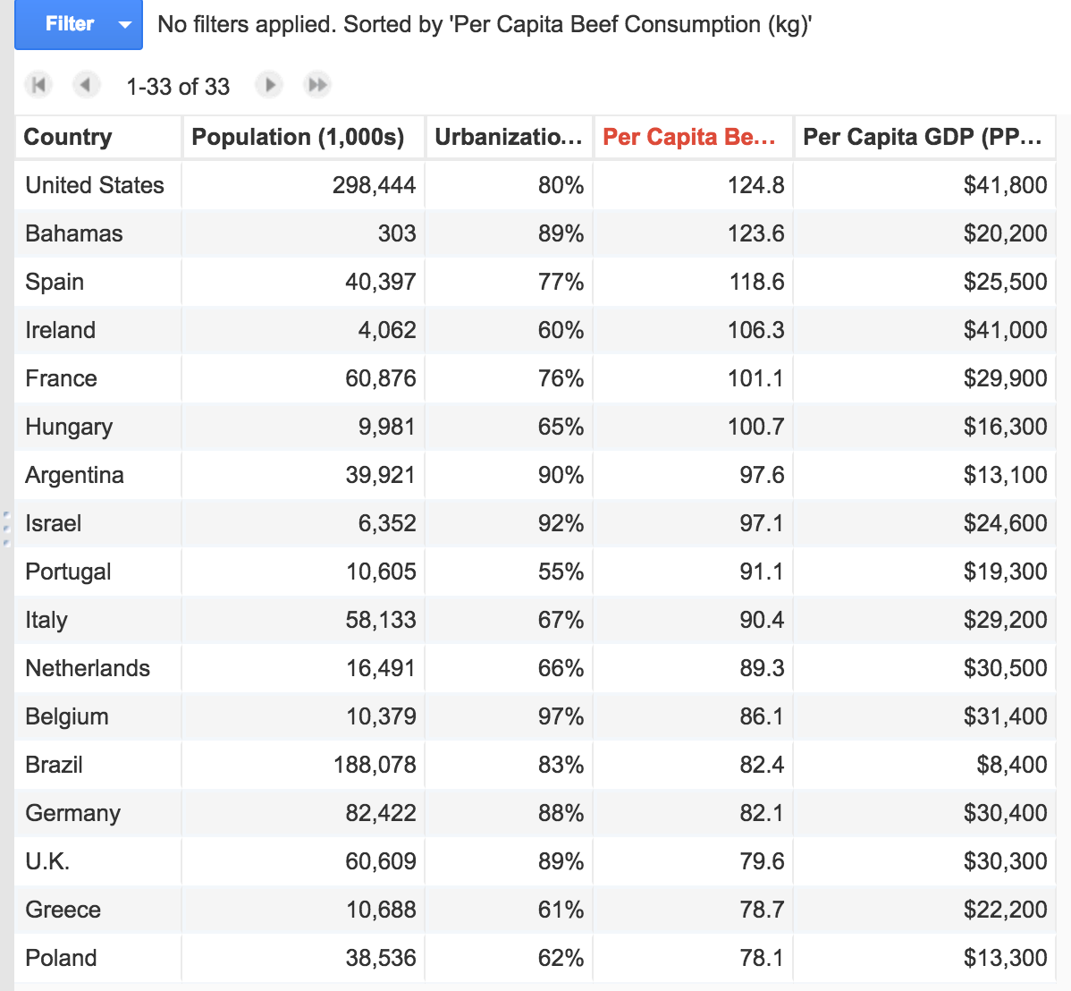Exhibit 3: Data Table

Since beef consumption is the most important criteria for a steak house, I have created exhibit 4 to be able to see each country’s beef consumption with bar plot. Beef consumption is the same category of data for each country, that is why I used bar plot. Bar plot gives me a visual view of data about beef consumption.

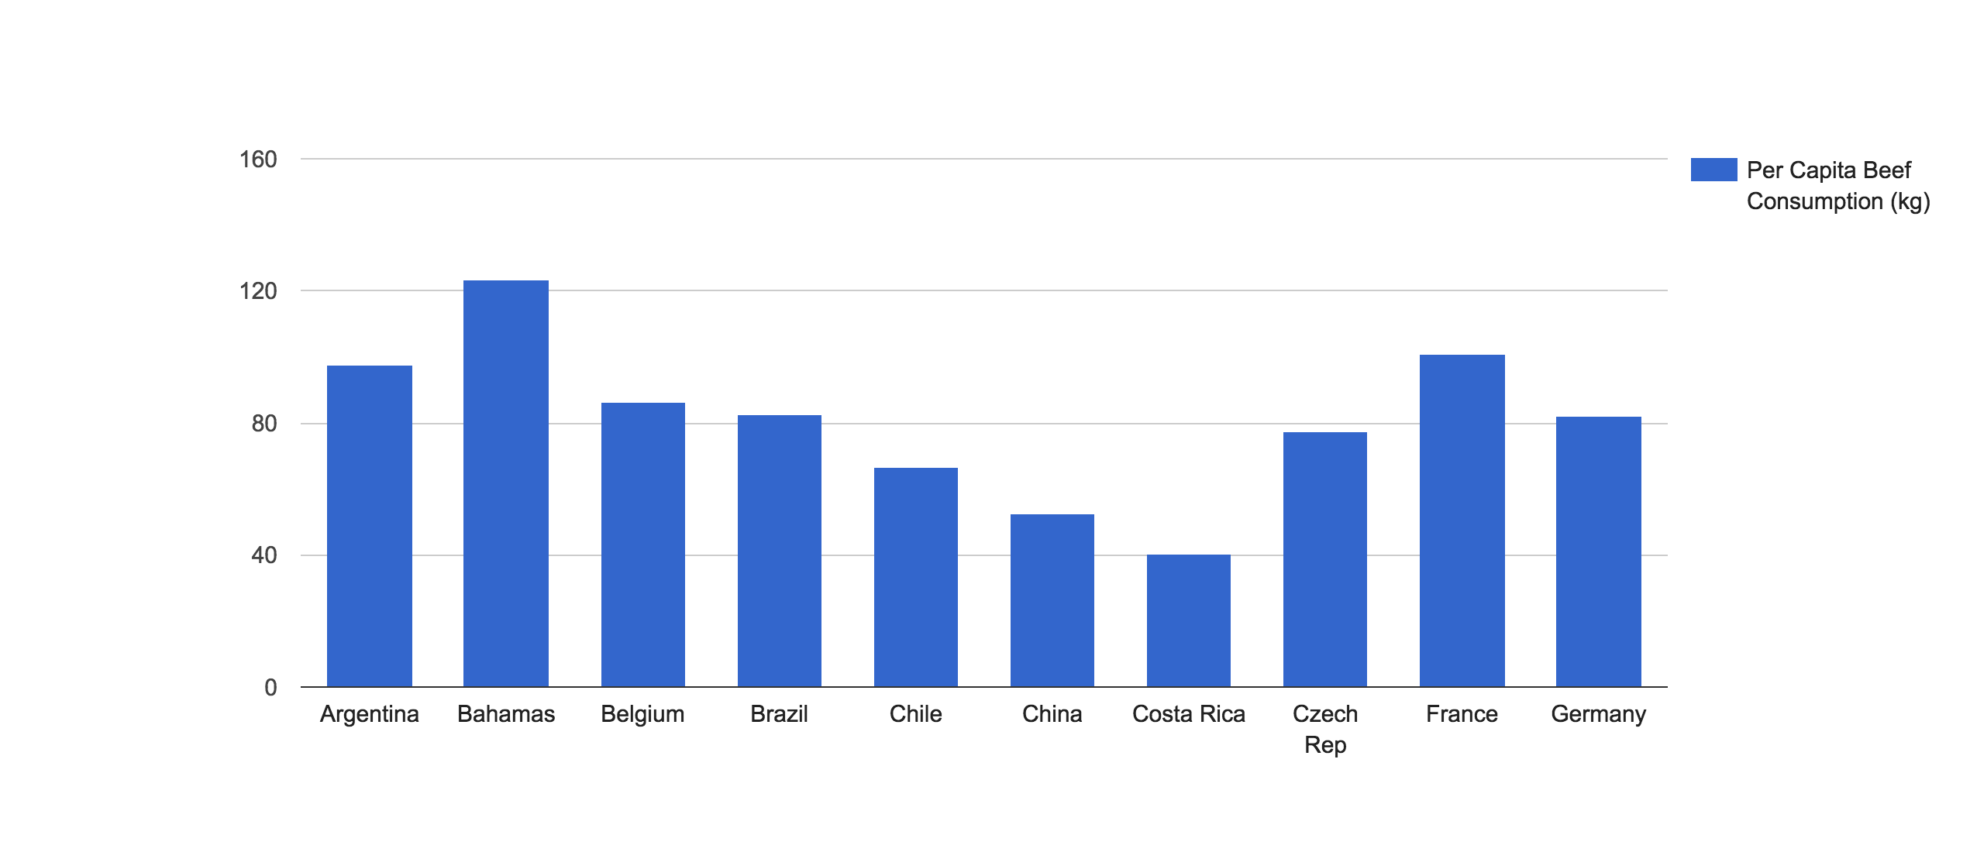Exhibit 4: Per Capita Beef Consumption

Exhibit 5 shows the meet consumption growth rate for region. I am likely to see which region could be a better decision to expand.

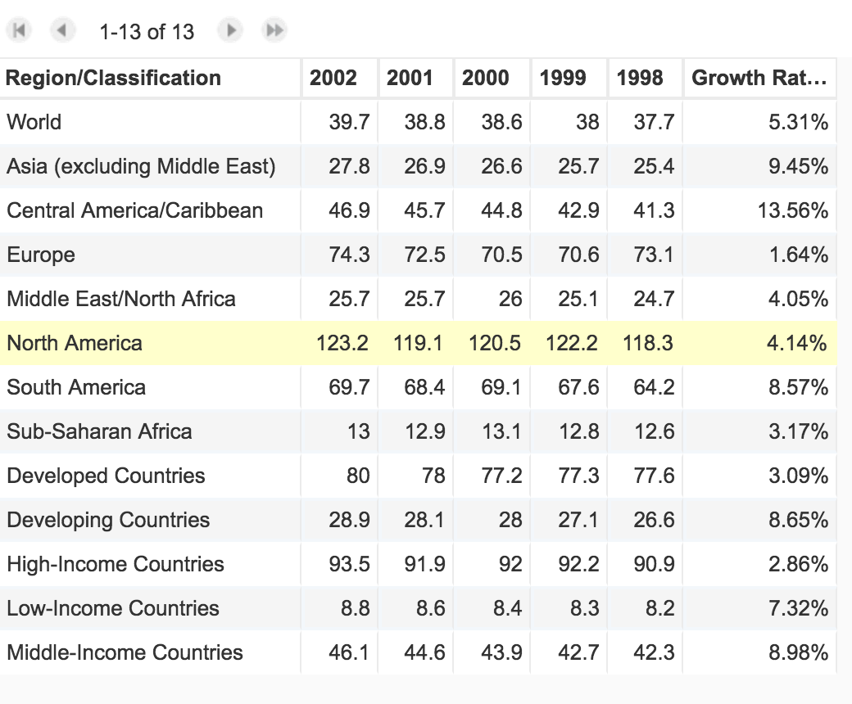Exhibit 5: Meet Consumption Growth Rate

I have created another bar plot for per capita GDP. Exhibit 6 shows the GDP for each country.

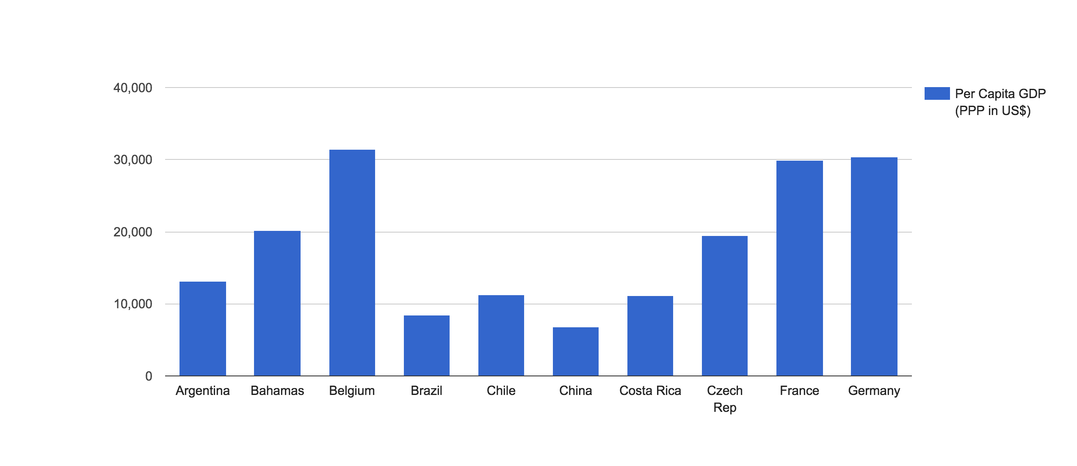Exhibit 6: Per Capita GDP

Finally, I have created bar plot for population to see how many customer I can target if I expand to that country.

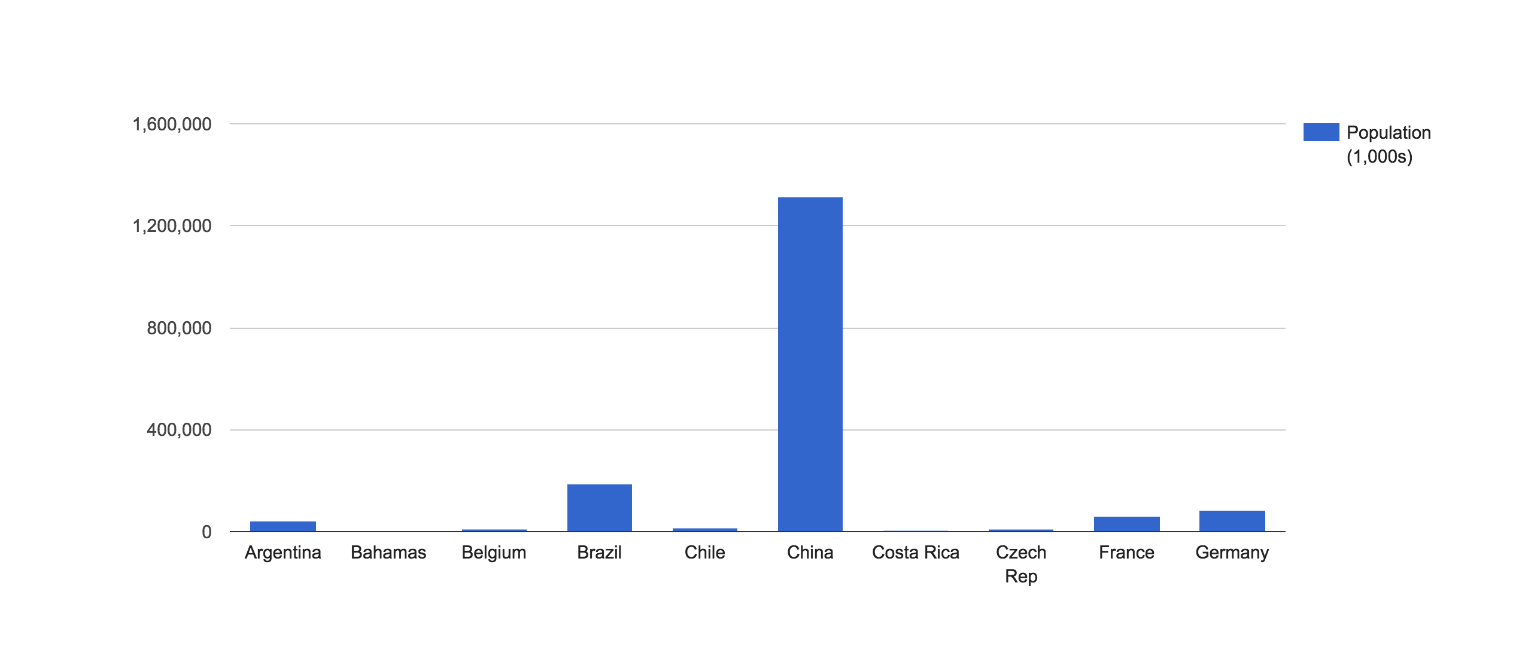Exhibit 7: Population

1. **Conclusion**

I have considered other factors such as war and political uncertainty that could affect my business goals in the possible country. Currently, Middle Eastern counties have been facing civil war, so it might be quite risky to expand in these countries. Therefore, I eliminated the countries from the Middle East. Also I asked myself which decision would fit my business goals.

After my analysis, I have come to conclude with my first 6 alternatives that have more weighted score are China, USA, Brazil, Japan, Russia and Germany. China got the 1st rank due to its massive population. However, it has pretty low per capita beef consumption, per capita GDP, and urbanization rate. For these reasons, I eliminated the China option. For USA option, Ruth’s Chris has enough restaurants in the USA. The business decision is to expand to a new country, so I skipped USA options. For Brazil, Japan and Russia options, they have a low per capita beef consumption or per capita GDP rate. Based on my charts, decision matrix, and business intelligence, my suggestion for Ruth’s Chris is to expand to Germany. Germany is likely to be the optimal business decision for expansion. Germany decision can meet Ruth’s Chris business objectives. It has 82.1 per capita beef consumption, $30,400 per capita GDP, 82,422 population (1,000s), and 88% urbanization rate.

Reference

Alon, I., & Kupetz, A.H. (2006, January 20). Ruth’s Chris: the High stakes of international expansion. Retrieved from <https://cb.hbsp.harvard.edu/cbmp/context/coursepacks/38321803>

Decision making confidence. (n.d.). Retrieved from <http://www.decision-making-confidence.com/explain-the-decision-making-process.html>

Decision matrix. (n.d.). Retrieved from <http://www.businessdictionary.com/definition/decision-matrix.html>

Marci, M. (2016, August 19). Decision Matrix: What is it and how to use it. Retrieved from <http://www.businessnewsdaily.com/6146-decision-matrix.html>

Mulcahy, R. (2007, March 6). What is business intelligence? Retrieved from <http://www.cio.com/article/2439504/business-intelligence/business-intelligence-definition-and-solutions.html>